[**CURRIED BEEF, BROCCOLI SLAW, & MUSHROOM FRITTATA MUFFINS**](http://nomnompaleo.com/post/3397688384/curried-beef-broccoli-slaw-mushroom-frittata)

[864](http://www.pinterest.com/pin/create/button/?url=http%3A%2F%2Fnomnompaleo.com%2Fpost%2F3397688384%2Fcurried-beef-broccoli-slaw-mushroom-frittata&media=&guid=UxEaFXmmHH2D-0&description=Curried%20Beef%2C%20Broccoli%20Slaw%2C%20%26%20Mushroom%20Frittata%20Muffins%20%7C%20Award-Winning%20Paleo%20Recipes%20%7C%20Nom%20Nom%20Paleo)

It’s no secret that I love frittatas. They’re even better in mini form ‘cause you can serve them as finger food at a party or store them in the fridge for a quick snack or breakfast on the go. I threw this recipe together this morning for the inaugural [CrossFit Palo Alto Whole9 Nutrition Guide Orientation](http://www.crossfitpaloalto.com/2011/02/10/nutrition-guide-orientation/" \t "_blank). Luckily, they turned out okay or I would’ve had egg on my face. (Ha!)

Mini frittata muffins can be made with whatever you have lying around, just like regular sized frittatas. Just fill up the muffin tins with filling and you can estimate the amount of eggs you need to make the batter with this ratio: for every two muffins, you need one egg in the batter (e.g. 12 muffins = 6 eggs). If you don’t want your mini frittatas to be too moist (i.e. soggy), add a few tablespoons of coconut flour. (For 15 muffins, I’ll put in 3 level tablespoons of coconut flour).

**Here’s what I assembled to make 36 muffins:**

* 1 onion, diced
* 1 heaping tablespoon of coconut oil
* 1 pound of mushrooms, thinly sliced
* 1 bag of broccoli slaw from Trader Joe’s
* 1 pound of grass fed ground beef
* 1 heaping tablespoon of curry powder
* coconut oil spray
* ½ cup coconut milk
* 20 large eggs
* 5-6 tablespoons of coconut flour (optional, see note above)
* Kosher salt
* Freshly ground black pepper

**Here’s how I made them:**

I preheated the oven to 375 F and I started chopping and slicing my veggies.

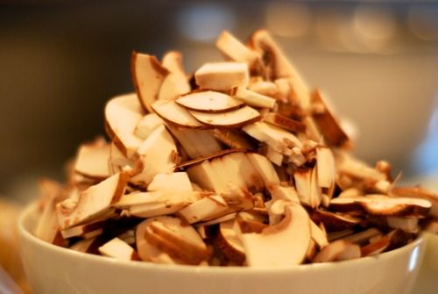

I heated up the coconut oil in a large cast iron skillet over medium heat. Once the pan was hot, I threw in the onions with some salt and pepper and sauteed them until they were soft and translucent.

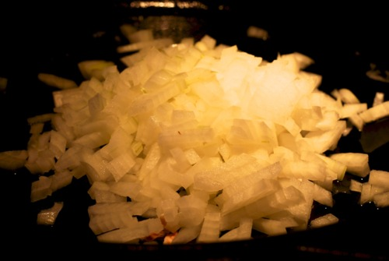

Next, I added the mushrooms (with some more S&P) and cooked them until the liquid had evaporated.

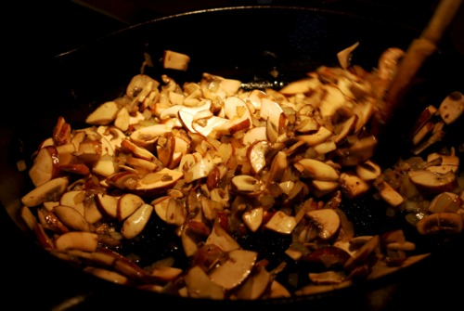

I tossed in the ground beef and cooked it until it was no longer pink. I seasoned the meat mixture with the curry powder and added more salt and pepper to taste. Then, I added the bag of broccoli slaw…

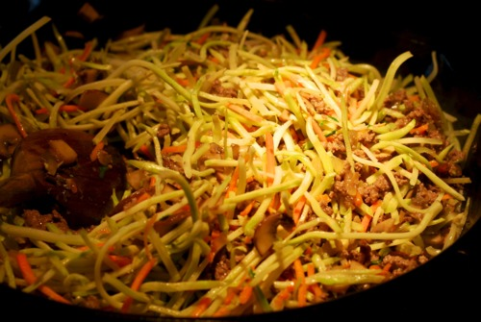

…and stirred that around until the slaw was softened.

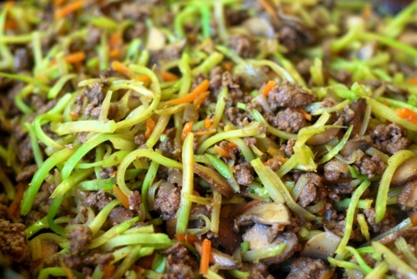

In the meantime, I had my two boys help me put cupcake liners in my cupcake tins.



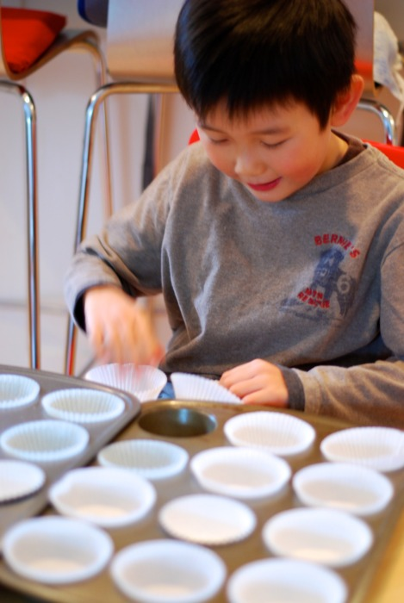

Once the liners were in the tins, I sprayed them with coconut oil spray. If you coat the liners with oil, the muffins won’t stick as much to the paper. (Or you can skip this part and use [silicone baking cups](http://www.amazon.com/gp/product/B000UGPJEQ?ie=UTF8&tag=f05f-20&creativeASIN=B000UGPJEQ).)

Next, I divided the filling into each muffin liner.

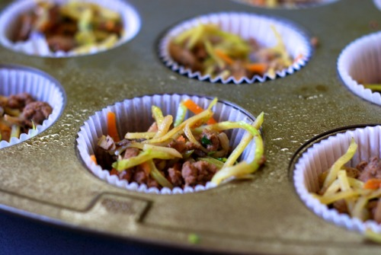

I cracked the eggs into a large bowl and whisked in the coconut milk and a healthy sprinkle of salt and pepper.

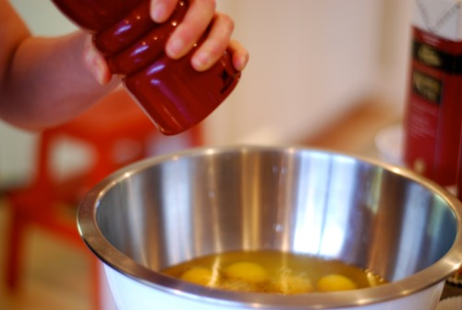

I know this might sound gross, but I tasted the raw egg mixture to make sure there was enough seasoning. Yes, [CrossFit Palo Alto](http://www.crossfitpaloalto.com/" \t "_blank) members, I risked salmonella poisoning for you guys.

I ladled the egg mixture into the muffin tins, making sure the liquid only reached 3/4 of the way to the top. The muffins puff up during cooking so you don’t want to fill them to the brim.

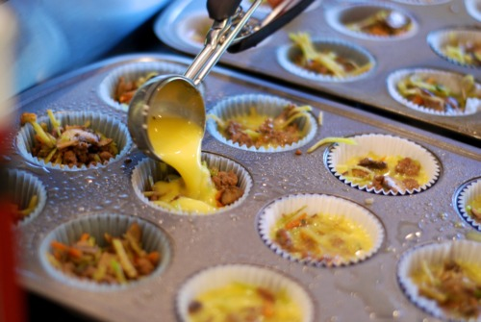

I popped the trays into the oven for 15 minutes and then I rotated the trays and baked them for 6 additional minutes. You know the muffins are done when they rise up to the top and they are springy to the touch when you pat the surface. I let the muffins sit in the pan for a few minutes and then I cooled them on a wire rack.

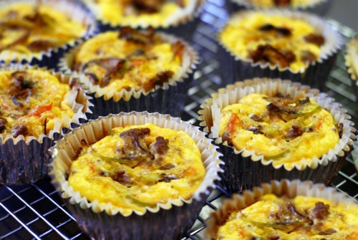

These muffins can be served warm, room temperature, or cold right out of the fridge. I know I’m beating a dead horse, but frittatas really are awesome.

[UPDATED: [I’ve since made these frittatas using silicone baking cups, and it’s a GAME-CHANGER](http://nomnompaleo.com/post/3829813349/le-creuset-silicone-baking-cups-game-changer) — I’m not going back to paper cupcake liners!]